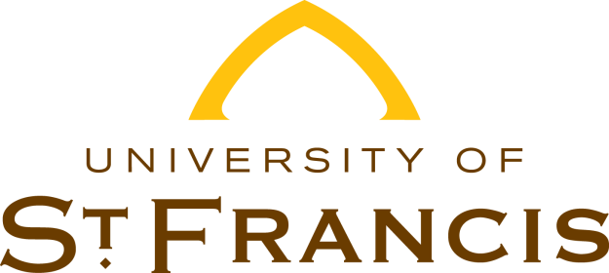

Dear USF Student,

This letter is in regards to your upcoming or recent separation from the University of St. Francis.

You must complete exit counseling when you leave school, graduate or drop below half-time enrollment. The purpose of this exit counseling is to ensure you understand your student loan obligations and are prepare for repayment. During the exit counseling, you will learn about what your federal student loan repayment will look like after school.

Our records show that during your enrollment at University Of St. Francis you borrowed federal direct loans from the Department of Education. As you make plans for your separation from USF or look forward to the completion of your program, you may have questions regarding the educational loans you borrowed and repayment options available. The Exit Counseling will assist you in preparing for the repayment of your educational loans.

To complete the exit counseling go to <https://studentaid.gov> under **LOAN REPAYMENT**. The exit counseling takes about 30 minutes to complete. You must complete it in one session; you cannot save and return to an incomplete session. You will need your FSA ID username and password. You will also need to update your contact information.

Best wishes on your professional endeavors as you leave the University of St. Francis. Please call our office at (815) 740-3403 or toll-free at (866) 890-8331 if you have any questions or need assistance in completing this required exit counseling.

Sincerely,

Financial Aid Services