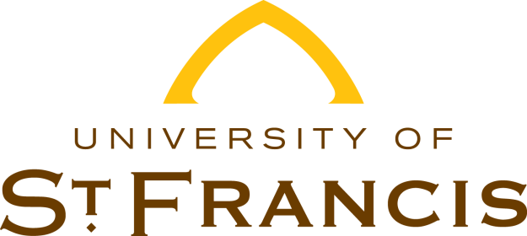

**NOTIFICATION OF LOAN DEFAULT STATUS**

**2025-2026**

Financial Aid Services has received the output of your current Student Aid Report (SAR) electronically. A copy of this updated SAR was sent to you electronically. The comment section on your SAR from the federal processor states that you are currently in Default on a federal student loan.

Under federal law, Financial Aid Services cannot process any federal or state financial aid for you until this issue is resolved. The following are telephone numbers of federal agencies that you can contact to resolve this matter: U.S. Department of Education at (800) 621-3115. You will need to contact the lender(s) and/or the school(s) holding the loan(s).

It is the student’s responsibility to provide documentation indicating resolution of this loan Default status. This documentation must be received and processed by Financial Aid Service within the term of attendance for any assistance to be received. If you have other questions, please contact our office at (815) 740-3403, toll-free at (866) 890-8331, or by e-mail at finaid@stfrancis.edu.

Sincerely,

Financial Aid Services

Please send your documentation to:

**Financial Aid Services**

500 Wilcox Street Joliet, IL 60435 | finaid@stfrancis.edu

(815) 740-3403 | Toll-free: (866) 890-8331 | Fax: (815) 740-3822